DELEGATE REGISTRATION FORM
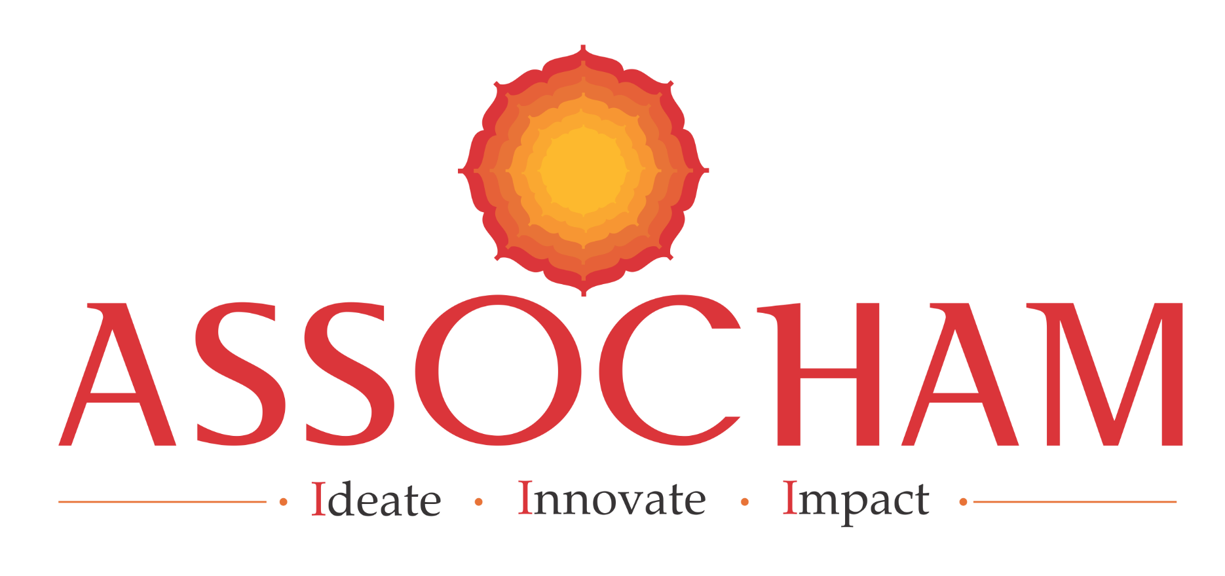
14th CAPITAL MARKET SUMMIT
“The Re-set of Globalisation: Capital Formation @2047 for New India”
February 22, 2023 - Hotel Four Seasons, Mumbai

I / we would like to attend / nominate the following:

S. N. | Name | Designation | Mobile | Email

1.
2.
3.
4.
5.

PARTICIPATION FEE: Rs. 3,000 per participant. The fee is inclusive of taxes, refreshment and lunch.

Cheque of Rs. ……………. Dated ………………….. drawn on …………………….. being participation fee in favour of “ASSOCHAM” payable at New Delhi, is enclosed.

ORGANISATION DETAILS

Company: …………………………………………………………………………………………………………………………………………..

Address: …………………………………………………………………………………………………………………………………………….

Telephone ………………………………………………………. Fax …………………………………………………….......

GSTIN No. …………………………………………………….......

ONLINE PAYMENT DETAIL (If required)

Bank Name: HDFC Bank
Address- 4/48, Malcha Marg Shopping Complex, Chanakyapuri, New Delhi-110021
Beneficiary Name: ASSOCHAM
PAN No: AAATT4704C
Bank Account Number- 05031110000062
IFSC Code- HDFC0004711
MICR Code- 110240432
Swift Code- HDFCINBB

Note: Prior Registration is essential. Please email/ courier the registration form at the earliest.
Please send the registration form to Address given below:

ASSOCHAM, 4th Floor, YMCA Cultural Centre and Library Building, 01 Jai Singh Road, New Delhi – 110001

For further details please contact:

Mr. Ankit Krishna  Ph: 7838567953  e-mail: ankit.krishna@assocham.com | Mr. Pradeep Gupta  Ph: 9818151246  e-mail: pradeep.gupta@assocham.com

